the update statement allows us to modify one or more existing records in our table at the same time.

Now in this example, we're just going to focus on updating one record.

But to update multiple records, the same sort of thing applies. So just as with the insert statement. We first of all would declare a work area. We would then fill our work area with the data that we want to update the record with, and then proceed to execute the update statement which would take our data, update the record in the database. And then give us back a return code to tell us if the update was successful or not.

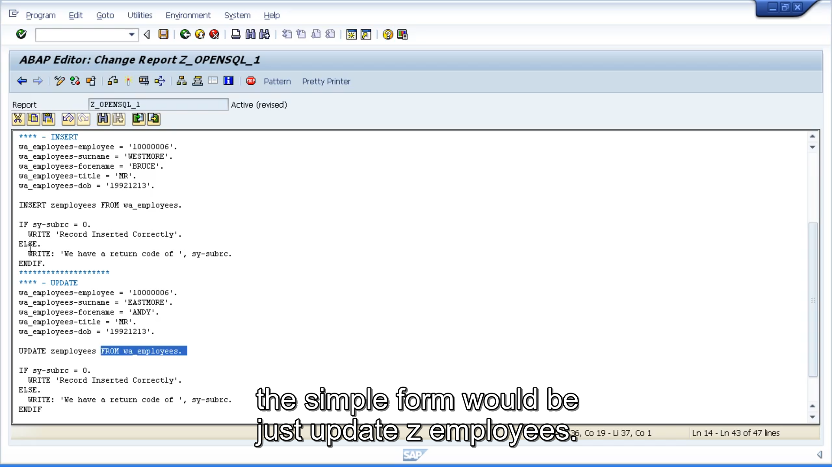

So, as we have already got a table structure. what we will do is change these contents. So, we will let this insert statement run through. Insert the record, and then we will update it with some new values.

instead of insert, we will use update. And just like the insert statement, the simple form would be just update z employees. And that would update using the head of record.



But as we don't want to do that, because it's the old way of doing things, we want to use our separate work area. So back in our program, we would say update z employees from our work area. So that's it, we don't need to do any more coding.